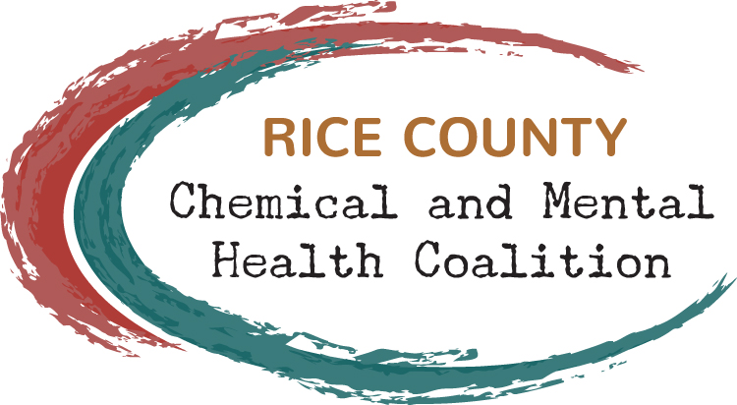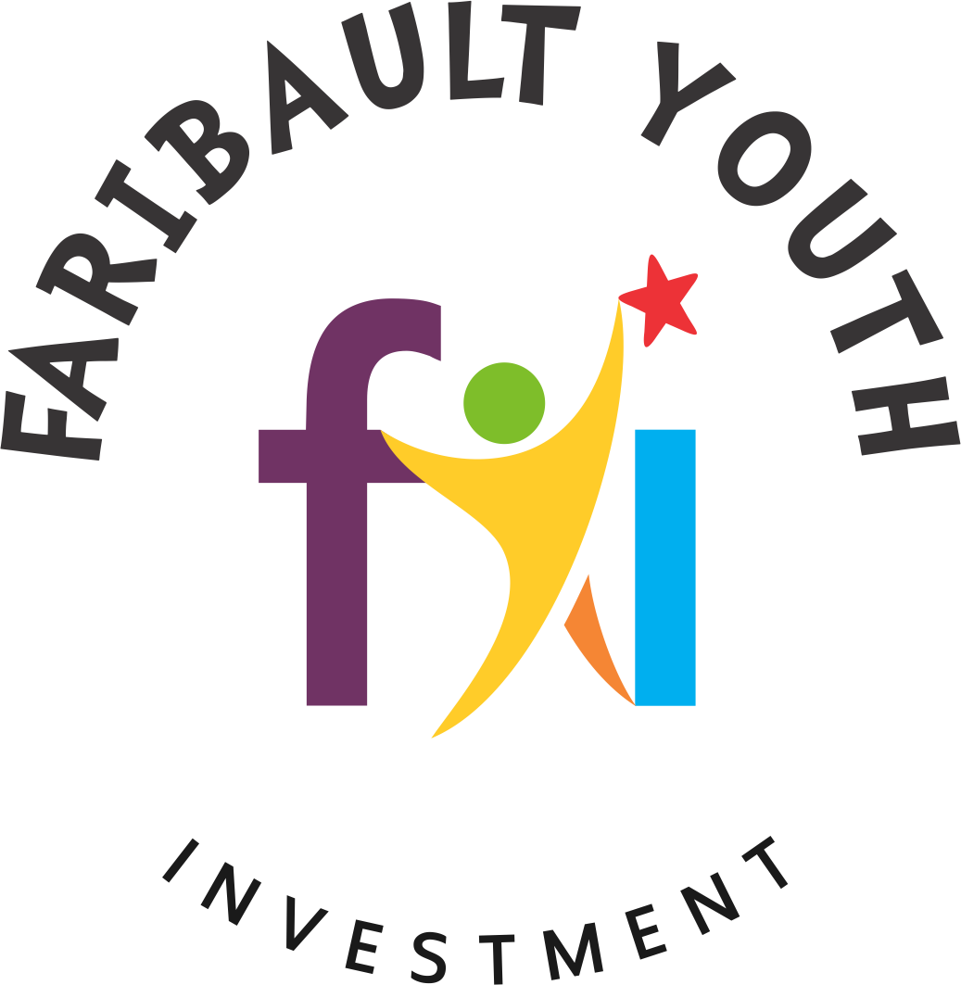

School Prevention Curriculum Request for Proposals
* Applications due May 1, 2019 *

Please submit completed applications to Becky Ford (becky@faribaultyouthinvestment.org).

School Name:

Contact Person for this Application:

Contact Person’s Telephone Number:

Contact Person’s Email Address:

Project Details:
Describe the process undertaken to review and select the proposed curriculum/program. Specify how young people, in particular, were involved in the review and selection.

Which curriculum/program did you ultimately select? Please list the name of the curriculum or program and the organization that produces it. Please also provide a website address for the curriculum/program, if applicable.

When will this curriculum/program begin being implemented? What training will be provided and who will participate in the training?

What students will receive the curriculum/program? How many Rice County youth will receive it during the first year?

How often will the curriculum/program be implemented moving forward?

Describe and provide documentation that the selected curriculum/program is evidence-based (This can include printing off the summary page about the program from a recognized national clearinghouse of evidence-based programs; please contact the Rice County Chemical & Mental Health Coalition staff with questions about documentation requirements).

Financial Request

Provide a detailed budget for the implementation of this curriculum/program, including the total cost.

How much are you requesting in grant funds?

How much of the total cost can your school/school district contribute? What other in-kind contributions do you anticipate making to the project?

Important Notes
If funding is used to purchase curriculum/programs, please understand that the curriculum/programs must be implemented for at least four school years or the applicant will be expected to refund part of the purchase price to the Rice County Chemical & Mental Health Coalition and Faribault Youth Investment.
- Implemented 0 years – refund 100% of cost
- Implemented 1 year – refund 75% of cost
- Implemented 2 years – refund 50% of cost
- Implemented 3 years – refund 25% of cost
- Implemented 4+ years – no expectation to refund

Also, funded projects will be required to submit very short annual reports (less than one page) for the next four years, summarizing implementation of the curriculum and number of students served.

Applicant Signature: Date:

Administrator Signature: Date:

