In honor of National Substance Abuse Recovery Month
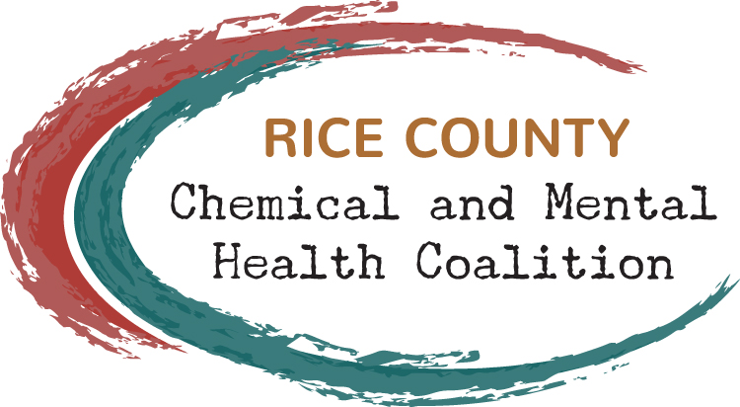
Prevention Champion
Nomination Form
A Prevention Champion is someone who has helped provide support for a healthier life in our community… someone who helps reduce risk factors for alcohol and drug abuse, someone who supports recovery, someone who promotes mental health and well-being, someone who builds assets for our youth and other community members.

Nominator Name:

Address:

Phone: E-mail:

Nominee Name(s):

Address:

Phone: E-mail:

Affiliation:

Please briefly describe why you believe this person or group should receive the Prevention Champion recognition. If possible, please provide a story that illustrates her/his (if the nominee is an individual) or their (if the nominee is a group) commitment. Nominations do not need to be long!

Return nomination to RCCMHC 340 9th Street SW #5958, Faribault, MN 55021 or Katie@northfieldhci.org
DEADLINE FOR SUBMISSION: September 27, 2019

